Name :Sk.kashifa

Register no :192121135

Experiment 2 -Exam registration system

Usecase diagram :

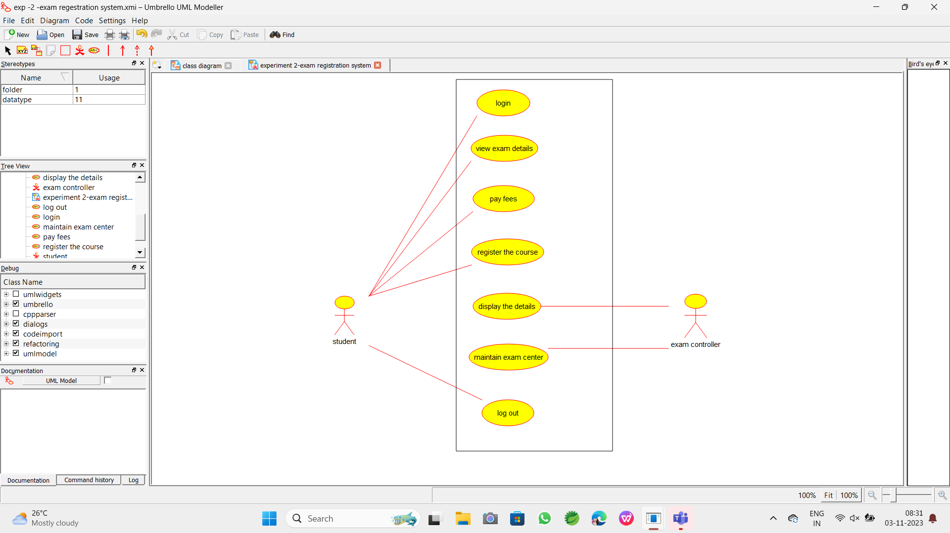

Class diagram :

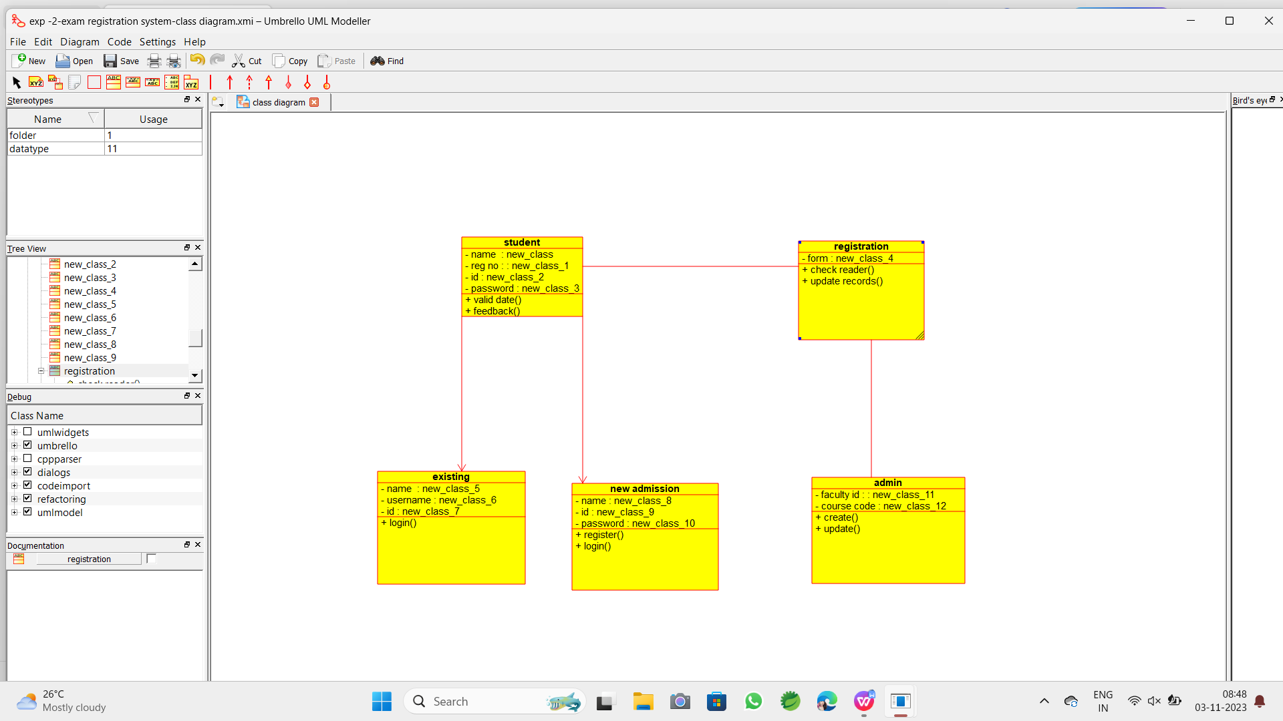

Sequence diagram :

